Walter Dean Myers
1937-2014
“Young people need ideals which identify them, and their lives, as central guideposts which tell them what they can be, should be and indeed are.”

Myers was born in 1937 in West Virginia, but spent most of his life in Harlem NYC.

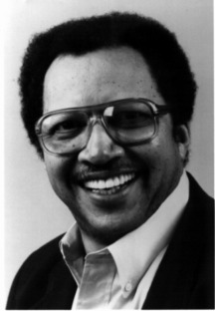
Myers mother died while giving birth to his little sister leaving Myers to be raised by foster parents. His life was happy but chaotic.

Myers grew up with a speech impediment. Writing became a habit and he acquired an early love of reading.

In 1954, Myers quit high school and joined the army. However, a teacher who had recognized Myers talent and suspected he was on the verge of dropping out of school, advised him to keep on writing no matter what happened.

Later on, while working a construction job, Myers began writing late at night about his difficult teen years.

Myers spent his later years living in Jersey City, New Jersey with his family where he wrote and volunteered at city schools.

Myers was the recipient of the Margaret Edwards Award from the American Library Association (1994) and nominated for the International Hans Christian Andersen Award (2010).

Myers has written over one hundred books and in doing so, has won the Coretta Scott King Award for African-American authors five times.

On July 1, 2014 Myers died in Manhattan.

